Thermal Barrier Coating
Student’s Name
Institutional Affiliation

Table of Contents
Introduction 3
Structure of Thermal Barrier Coating System 4
Modes of Thermal Barrier Coating Failure 6
Plasma Sprayed Failure 8
Life Time Prediction 11
Conclusion 12
References 14
Appendices 15

Thermal Barrier Coating

Introduction
A thermal barrier coating is a system that is highly advanced and used in machine services to exhaust and manage heat. Recently it has been used in gas turbines and aviation engineering. In terms of its composition it consists of a refractory oxide that has a ceramic coating which is usually applied on hot metallic services (Felten, 1976). Other studies inform that thermal barrier coating is used as an insulation material for structures with elevated temperature. It is well known that coatings allow the effect of higher temperatures that goes beyond the metallic limit without damaging the inner material. Apparently, the thermal coating material is a two in one component containing not only the top coat ceramic oxide material but also contains an underlying super alloy layer in between that further insulates the material embedded. Generally, the thermal barrier coating contains four layers which include, metallic substrate, ceramic top coat, oxide grown thermally, and metallic bond coat (Haynes, 2002).
Besides it also contains a stabilized zirconia which provides low heat conductivity as well as stabilizing nominal temperatures for decision operations of machines. As a result of this properties, thermal barrier coating has recently developed an extensive use in industries and automotive settings. For example, the automobile systems have been found to benefit much from this material since they highly use high sensitive temperature materials such as turbochargers, downpipes, exhaust manifold, and tailpipes (Klemens, 1998). The thermal barrier coating provides insulation properties in this component and as well as regulate thermal exposure and friction to prolong material structure life and prevent rampant oxidation. Moreover, thermal coating machine prevents melting as well as enhancing efficient energy conversion that stabilizes the engine materials as well as preventing deterioration and waste of gas inlets.

Structure of Thermal Barrier Coating System
An effective thermal barrier system must meet certain parameters to have good performance in thermal mechanical systems. To start with porosity is one of the requirement needed for a thermal barrier system to be aggressive. It involves use of porous foam in the exhaust gas that aids heat recovery as well as reducing gas emissions (Maloney, 1999). This entirely enhances engine efficiency and thermal properties of the entire system. It also helps in environmental conservation by enhancing homogeneous combustion and heat recovery. In material engine it happens that porosity is highly required to handle the stresses of thermal expansion as well as matching the thermal coefficients in an automotive system. Porous material therefore remains a vital requirement for an effective thermal barrier coating structure as far as efficiency in machine services and heat conservation, is concerned (Meler, 1994).
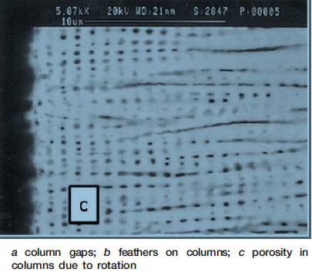
Figure 1:Porosity Structure
In addition to this, phase stability is also considered when designing the structure of a thermal barrier coating system. Phase stability refers to standardization of the air volume changes in a system where a field passes in a zero to maximum alteration (Rickerby, 1999). In this case, a phase change enhances air breathing in engines. For example, during mechanical part rotation, oxidation resistance occurs and aid machine breathing. Other properties considered when formulating the structure of thermal barrier coating include, high melting capacity, zero phase transformation between operating and room temperatures, chemical inertness, negligible thermal conductivity, adequate adherence to substrate and low rate of sintering for porous microstructure (Sission, 1985).
From these properties, four structural layers of a thermal barrier coating are formulated to give a structure of the TBC. They include, metallic bond coat, metal substrate, ceramic topcoat and thermally grown oxide. Each of these layers have specific roles and chemical properties to provide a desired function of the thermal barrier coating. The ceramic top coat acts as a protection covering the embedded material. It is the most top layer that protects the metallic material from corrosion and erosion (Shillington. 1999). The metallic bond coat prevents oxidation of the superlloy substrate. It also aids in balancing the thermal mismatch between the substrate and the topcoat as well as preventing interdiffusion that occurs in the elements that makes the bond coat and the substrate. In this case interdiffusion refers to a reactions that happens between the elements that make up the substrate and the bond coat.
The top coat thermally grown oxide is a material that consist spinel phases which appear thermodynamically unstable, as well as prone to oxidation resistance. The materials that arise as a result of spinel phase integration aid in improving the bonding between ceramic topcoat and bond coat. The bond coat is a polymer structure that defend the embedded material from corrosions and other environmental damages. The metal substrate is a superlloy made up of three materials that is polycrystalline, single crystal and directionally solidified crystals (Acta, 1997). In a thermal barrier coating system, interdiffusion occurs between the bond coat and the substrate. That is a chemical reaction between the elements of the individual materials. This interdiffusion poses negative effects on the mechanical properties and the cycling lifetime of the thermal properties of the TBC material. The metal substrate therefore acts as a reducing agent of interdifussions and therefore prevent the material from forming the secondary reaction zone and the topological close pack that deteriorates the effectiveness of the material on metallic parts (Zhang, 2001). The figure below shows the structure of the thermal barrier coating.
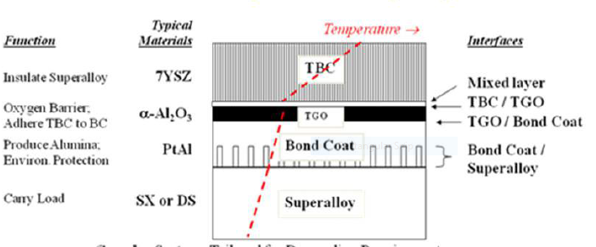
Figure 2:Thermal Barrier Coating Structure

Modes of Thermal Barrier Coating Failure
Usually, thermal barrier coating provides thermal benefits to components when coating integrity is preserved. However, it happens that maintaining coating integrity for the thermal barrier coating appears to be difficult than In other metallic coating since the change of material properties in a thermal barrier system coating is relatively high compared to other incidences (Acta, 1997). Change from metallic substrate to ceramic coating is one of the property that mostly degrades TBS effectiveness. Normally, maximum usage of TBC depends on their level of susceptibility to failure. Generally, there are four types of TBS failure, they include, spallation, plasma sprayed failure, EB-PVD failure, and erosion (Zhang, 2001).
Spallation is a mechanical TBS failure that manifests by removal of the ceramic layer caused as a result of delamination of the bond coat. There are many processes that may trigger spallation failure however, the two main known processes are thermal expansion mismatch between the metallic component and the ceramic top coat and the bond coat oxidation. The combination of this two effects results to a TBC failure since one leads to another. For example, delamination of the ceramic layer exposes the inner part to oxidation states that creates thermal expansion mismatch which further triggers mechanical spallation (Acta, 1997).
Existence of one defect say bond coat oxidation cannot lead to mechanical spallation. The entire defect results from the combination of the two. It therefore happens that this failure can be alleviated by reducing either of the two defects. Plasma sprayed failure also involves spallation only that it is accompanied by cracking (Sission, 1985). The delamination cracking results from compressive stresses that trigger tensile stresses in metallic materials. The tensile stress produces delamination cracking which appear parallel to the metallic interface as well as near the extreme edges of the rough bond coat. At times the stress might be greater than the one that appears on the peak of the bond coat. For example, TBC research shows that at the ceramic layer and the bond coat, are of two orders and of higher magnitudes than that of a smooth interface.

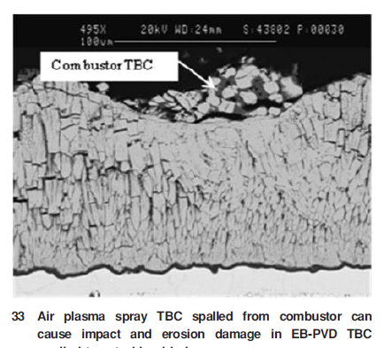

Plasma Sprayed Failure
From this analysis, it can therefore be noted that rough interface of a plasma sprayed TBS triggers delamination and reduction of the TBC lifetime (Meler, 1994). Further research shows that Delamination that occurs in plasma sprayed TBC failure are not as a result of single cracking rather they emanate from crack growth which progresses exponentially. Apparently, it also appears that delamination requires thermal fatigue for it to be exposed. Since thermal fatigue emanate from strain that are imposed on ceramic layer, it can be controlled by reducing the strain which can be done by reduction of thermal mismatch and oxidation.
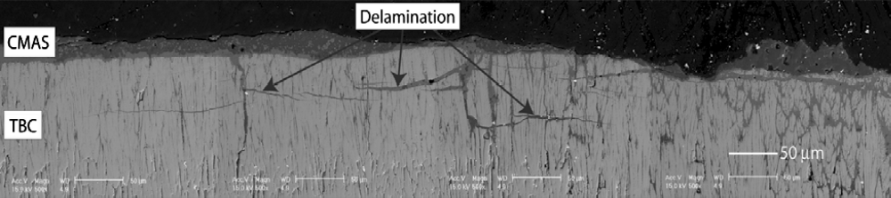
Figure 3:Delamination
EB-PVD TBC failure is a type of deterioration that emanates from failure that happens at the interface connecting the bond coat and the alumina scale ( Klemens, 1998). The position of the out of plane alumina tensile stresses determine occurrence of TBC failure by inducing the progress of the interfacial cracking that occurs on the in-plane strains. Seemingly, it happens that reduction of the adhesive force holding the alumina layer may also trigger TBC failure since it occurs at the interface connecting the alumina bond coat layer. Oxidation is also a potential threat towards the EB-PVD TBC failure since it triggers compressive stress that happens on the ceramic layer as a result if thermal cycling (Sission, 1985).
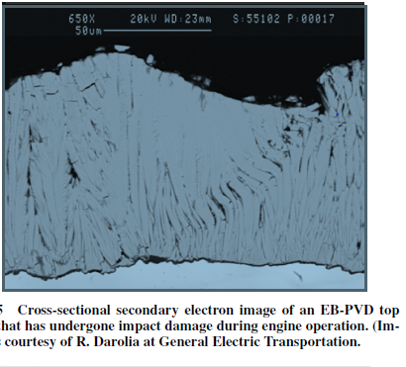
Figure 4:EB-PVD Failure
The TBC structure appears quite susceptible to erosion because of its crack like features. Furthermore, the distance between the cracks like features are relatively small which increases their susceptibility to erosion. In addition, the crack length that requires to be removed during coating appears smaller and therefore predisposes the material more to erosion as compared to other porous ceramics. The density of particulates in a material also determines its level of erosion (Acta, 1997). It requires that the degree of particulate loading be different for different environments. For example, it should be higher in aircraft engines to enable them in digest debris during takeoff. Erosion is a great element of failure in TBC Since it removes the ceramic layer there by depriving the material embedded the insulation advantages it gets from the ceramic layer (Zhang, 2001). To prevent effects of erosion on TBC research shows that designing a coating that is resistant to erosion is a key a strategy that can alleviate failure caused by erosion.
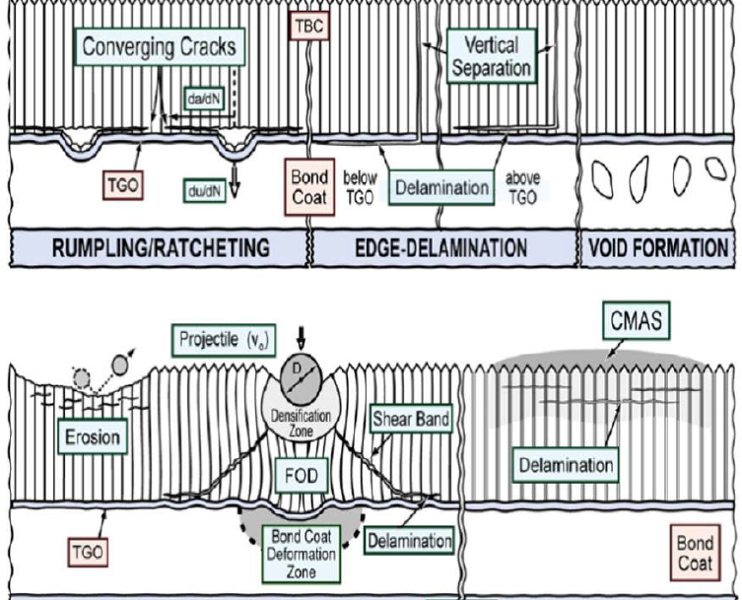
Figure 5:Entire Failure Mode TBC Structure

Life Time Prediction
As seen earlier, thermal barrier coating consists of ceramic coat and a metallic bond coat among other components. These two components have a mismatch between ceramic coat and metallic bond coat. The mismatch induces thermal fatigue and therefore the lifetime of the TBC decreases with increase in thermal fatigue and variation of temperature conditions which can lead to total TBC failure. From this analysis, it requires that the lifetime of the TBC should be predicted with respect to thermal fatigue and temperature degradation. One of the method that can be used to predict TBC lifetime is the bond test method. With respect to this method, a number of specimens are analyzed and their nomenclature identified (Klemenes, 1998). For example, the specimens can be heated under different time frequencies in terms of minutes. Say 15 20 and 30. The number of fatigue cycles can be denoted by N and the slope of the predicted equation be denoted by a. This slope can be compared to another slope without degradation say a* the relationship between the two slopes can be figured and the bond strength be determined with respect to time and rate of degradation.
Besides, stress development that occurs during thermal cycling can also be determined by use of finite element method. In this case, TBC stresses failure are compared numerically with that of top coating. As a result, it is found that the lifetime of TBC lies between 800 and 900 cycles which approximately agrees with that of experimental test which gives an approximate value of 860 cycles (Maloney, 1999). This value stands for 8 specimens and through this, other predictions can be made by varying different number of specimens. Moreover, failures of TBC can also be used to make TBC lifetime predictions. For example, TBC sintering, creep and TGO can be used as lifetime prediction parameters that can relate FEM formula to that of experimental results. In addition to this, thermal fatigue life can also be investigated to give a prediction lifetime of TBC (Acta, 1997). A number of specimens are analyzed at different pre-oxidation time using walker constitutive model and finite element method. The state of stress and strain between top coat and bond coat are analyzed using the meso scale and results proposed.

Conclusion
In conclusion, it can be deduced that thermal barrier coating is a system that is widely used in automobile engines and other machineries to manage thermal processes as well as other environmental aspects of metallic material. It has been found to contain four layers which has specific roles in the TBC material. All work together to enhance its insulation properties and thermal management. It is curbed with a number of failures which has been found to deteriorate its performance as well reduce its lifetime prediction. However, strategies have been cited that can be used to alleviate the profound failures. It has also been found that lifetime prediction on the TBC can be made using bond test and finite, element method and TBC failure specimen analysis. As a result, the lifetime cam guides the design of a good TBC material that is effective in mechanical engineering as well as other automotive aspects.

References
Acta Materialia, 1997 Thermal Barrier Coating Applications and Process Development for AirEngines,” Journal of Thermal Spray Technology, Vol. 6, No. 2, 1997, p. 167.
Felten, E. J., and Pettit, F. S.1976 “Development, Growth, and Adhesion of Al2O3 on Platinum-Aluminum Alloys,” Oxidation of Metals, Vol. 10, No. 3, p. 189.
Haynes, 2002“Influence of Sulfur, Platinum, and Hafnium on the Oxidation Behavior of CVD NiAl Bond-Coatings,” Oxidation of Metals, Vol. 58, Nos. 5–6,
Klemens, P. G., and Gell, M.,1998 “Thermal Conductivity of Thermal Barrier Coatings,” Materials Science and Engineering, Vol. A245, No. 2,
Maloney, M. J. 1999 “Methods for Generating a Ceramic Coating,” U.S. Patent No. 6,007,880, Dec.
Meier, 1994“The Evolution of Thermal Barrier1994, p. 250.
Rickerby, D 1999 “Thermal Barrier Coating for a Superalloy Article and a Method of Application Thereof,” U.S. Patent No. 5,942,337, Aug. 1999.
Sisson, Jr., 1985 “Protecting Gas Turbine Components,” Platinum Metals Review, Vol. 29, No. 1, 1985, p. 17. Shillington, E. 1999 Spalling Failure of a Thermal Barrier Coating Associated with Aluminum Depletion in the Bond-Coat,”
Zhang, 2001“Effects of Pt Incorporation on the Isothermal Oxidation Behavior of Chemical Vapor Deposition Aluminide Coatings,” Metallurgical and Materials Transactions A, Vol. 32A, No. 7, p. 1727.

Appendices

